**INDEX**

|  |  |  |
| --- | --- | --- |
| **SR.NO.** | **CHAPTER NAME** | **PAGE NO.** |
| **1** | **Introduction to Project**  Introduction to System  Modules of the system |  |
| **2** | **Organization Profile**  **Organization Chart** |  |
| **3** | **Proposed System**  Exitisting System  Need of Computerization  Objectives of System |  |
| **4** | **System Design**  Feasibility Study  Fact Finding Technique  Diagram  Hardware and Software Requirement |  |
| **5** | **User Manual**  User Guidline |  |
| **6** | **Input Screens** |  |
| **7** | **Output Screens** |  |
| **8** | **Limitations and Suggestions** |  |
| **9** | **Bibliography** |  |
|  |  |  |

**Chapter-1**

**Introduction**

**Introduction to system:-**

The **Online Voting System** is a digital platform designed to conduct elections securely and efficiently. It enables voters to cast their votes online through online voting system website. This system enhances **accuracy** by automating vote counting, reducing human errors, and ensuring quick result generation. Security measures such as encryption, authentication, and fraud detection help maintain election integrity and prevent unauthorized access. The system also improves accessibility, allowing eligible voters to participate from anywhere, increasing voter turnout. Transparency is ensured through verifiable audit trails, making the voting process fair and trustworthy. Additionally, online voting significantly reduces costs associated with traditional election methods, such as printing, manpower, and logistics. The **user-friendly interface** ensures that both voters and administrators can navigate the system effortlessly. Real-time monitoring features help officials track the voting process and identify any irregularities. Scalability allows the system to handle elections of varying sizes, from small organizations to large-scale government elections. Overall, the Online Voting System modernizes elections by providing a secure**,** fast, and transparent method for conducting democratic processes.

**The details of the system are as follows:**

An online voting system is a digital platform designed to facilitate elections by allowing voters to cast their votes online. This system is based on key principles such as security, transparency, accessibility, and accuracy. The process begins with voter registration, where eligible participants verify their identities to prevent fraud. Once registered, voters receive secure login credentials to access the online voting platform. During the voting phase, they select their preferred candidates through an encrypted digital interface. The system ensures fairness by preventing multiple votes from a single user and maintaining voter anonymity. After the voting period ends, the system automatically counts and verifies the votes, reducing the chances of human error and manipulation. Results can be published instantly, ensuring efficiency and transparency. Online voting systems may use various security measures such as encryption, two-factor authentication, and blockchain technology to prevent cyber threats and ensure data integrity. This system offers several advantages, including convenience, reduced costs, and accessibility for remote voters. However, challenges such as cybersecurity risks, digital literacy, and potential technical failures must be addressed to ensure the credibility of the election process.

Top of Form

Bottom of Form

**Modules of the system:**

**• Admin Registration Module**

**• Voter Registration Module**

**• Candidate Registration Module**

**•** Candidate **Management Module**

* Election Management Module

**• Vote Counting & Result Module**

**•** Security & Authentication Module

**• Admin Panel Module**

**• Notification Module**

**2.1 Organization Chart:**

Online Voting System

Admin Login User Login Candidate Login

│ │ │

Admin(Dashboard) Voter Dashboard Candidate Dashboard

(Cast Vote) (Cast Vote)

Election Management Candidate Management Voter Management

(Create & Manage) (Add & Verify) (Add & Verify)

**Chapter-3**

**Proposed**

**System**

**3.1 Existing system:-**

In traditional voting systems, elections are conducted manually using paper ballots or electronic voting machines. This process involves voter registration, physical polling stations, and manual vote counting, which can be time-consuming and prone to errors. In contrast, the existing **online voting system** has emerged as a digital alternative, allowing voters to cast their votes remotely via a secure web or mobile platform.

The current online voting systems generally require users to register with authentication methods such as passwords. Votes are cast online and securely stored in a database, ensuring accuracy and eliminating the risk of lost or tampered ballots. The system also allows for instant vote counting, reducing human errors and speeding up result announcements.

However, the existing online voting systems still face challenges such as cybersecurity risks, voter authentication concerns, and the digital divide. Despite these limitations, online voting systems are being adopted in schools, organizations, and even government elections to improve accessibility, efficiency, and transparency in the voting process.

**Drawback of Existing System:**

1. **Security Risks :**  The use of manual system in the “Online voting System” the large paper work is required for saving all details required for keeping record of each voter and candidate.
2. **Voter Authentication Issues:** Difficulty in verifying eligible voters, leading to risks of identity fraud or multiple voting.
3. **System Failures –** Technical glitches, server crashes, or internet disruptions can affect the voting process and accessibility.
   1. **Need of computerization**

Computerization improves efficiency, accuracy, and security in the online voting system. It automates vote counting, reduces human errors, prevents fraud, enables remote voting, minimizes costs, and eliminates the need for paper ballots. This ensures a fast, transparent, and reliable election process, making voting more accessible and efficient.

* **System Architecture & Design**
* **User Management**
* **Estimation and Costing**
* **UI/UX Design**
* **Financial Management**

**3.3 Objectives of system**

The main objectives of the system can be broadly classified as -:

1. To reduce costs
2. To enable real-time monitoring
3. To ensure transparency
4. To improve efficiency
5. To enhance accessibility
6. To provide a user-friendly interface
7. To ensure security
8. To ensure scalability

The primary objective of the Online Voting System is to simplify the election process and ensure a secure, transparent, and efficient voting experience through digital automation.

* As the system comprises various forms, it makes voter registration and election management easy.
* Due to computerization, searching for voter and candidate data is quick and efficient.
* This system is time-saving, as it automates vote collection, counting, and result generation.
* It eliminates the need for paper-based voting, reducing errors and ensuring eco-friendliness.
* Since the system is user-friendly, a single trained administrator can efficiently manage the entire election process.

**Chapter-4**

**System**

**Design**

**4.1 FEASIBILITY STUDY :-_**

The most important part of every system is the feasibility study. It provides technical, operation and economical feasibility. We discus all these parts in details.

• **Technical Feasibility**  
The online voting system will be developed using HTML, CSS, and JSP, ensuring compatibility with web browsers. The system requires a stable internet connection, a secure database, and server hosting to handle user authentication and vote processing. The available technology and development tools support the project, and the team has the necessary skills to implement it.

• **Operational Feasibility**  
The system will streamline the voting process, making it accessible, secure, and user-friendly. Voters can easily cast their votes online, reducing manual efforts and errors. It ensures real-time vote counting and eliminates long queues at polling stations. Proper training and user guidance will help in smooth adoption.

• **Economic Feasibility**  
The project reduces costs associated with paper ballots, physical polling stations, and staff salaries. Initial expenses include server hosting, security implementation, and maintenance, but in the long run, it saves money and increases efficiency. The investment is justified by the system’s benefits, making it a cost-effective solution.

* 1. **FACT FINDING TECHNIQUE**

In the development of the Online Voting System, the following methodology is adopted:

After selecting the project, permission must be obtained from the relevant authorities for designing and implementing the system. The system should address both advantages and limitations while fulfilling all organizational requirements. To achieve this, detailed information must be collected using various fact-finding techniques, such as interviews, questionnaires, observation, and document analysis.

A crucial aspect of system design is managing and organizing voter data, security protocols, and system logs effectively. All necessary documentation and programs must be prepared in a well-structured and organized manner.

Once the coding phase is complete, the system should be thoroughly tested using sample data to identify and fix any errors. Debugging must be done as required to ensure smooth functionality.

Finally, integration of all system modules is carried out to ensure seamless coordination between components. If all tests produce satisfactory results, the final implementation and deployment of the Online Voting System can proceed, generating the required reports and outputs.

* 1. **Diagrams :-**

**4.3.1 Context Level Diagram:**

**DATA FLOW DIAGRAM:-**

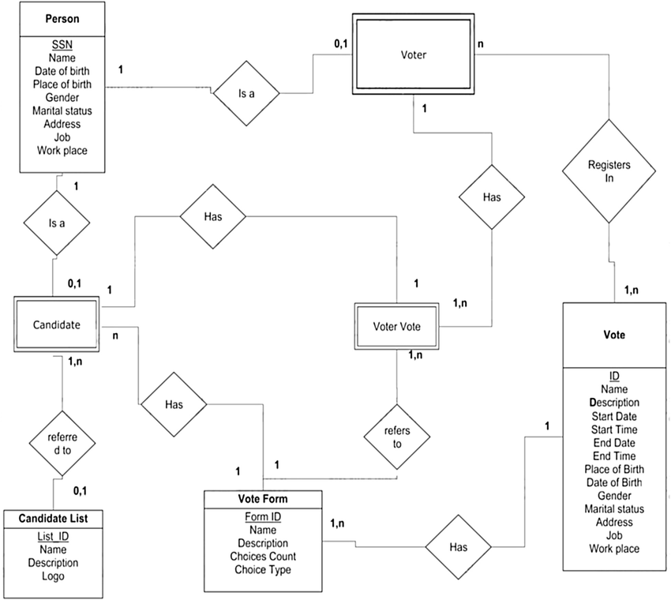

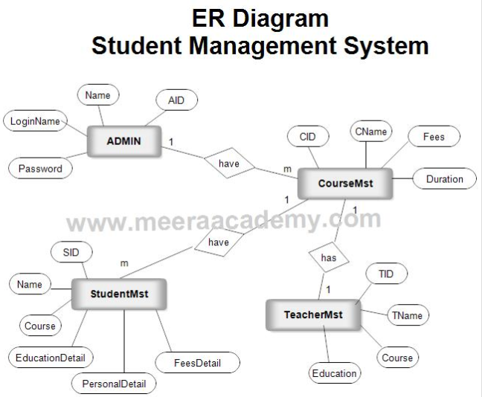

* **Hardware Requirements-**

1. Monitor 21”LED.
2. CPU-Intel P4, 2.66 GHz HT.2MB Cache.
3. 1 GB RAM.
4. 40 GB Hard disk (7200 RPM).
5. Optical Drive CD-RW 48X.
6. Multimedia Keyboard, Optical Mouse.

* **Software Requirements:-**

1. Windows O.S.(XP,2000,WIN8)
2. Microsoft office 2007
3. Microsoft Visual Basic.NET
4. Anti virus Software AVG, QH.
5. Crystal Report

The entire above are used hardware software requirement developing our project named “Hotel Management System”.

**Chapter-5**

**User Manual**

**5.1 User Guideline:-**

Menu Flow





Exit

Admin Login

User Signup

User login

Home



Add School

Personal details





Add Staff

View data



Parent details

Add Principal



School Fees







Reports

Logout

**Chapter-6**

**Input Screens**

**Login Form:-**



**MDI**:-

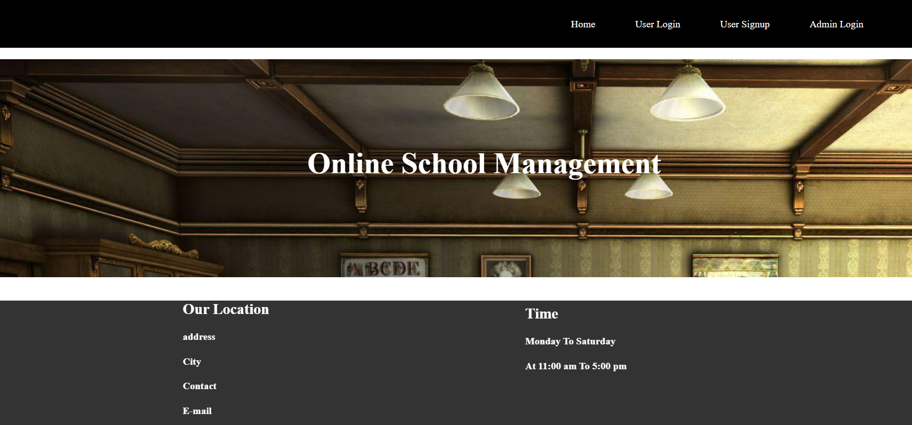

**Admin log:-**

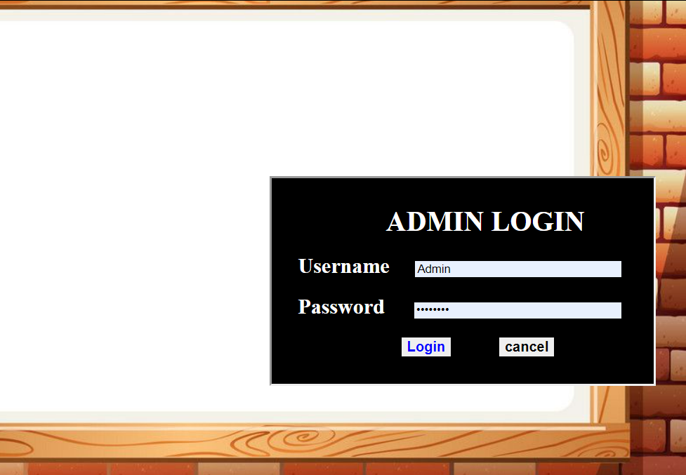

Master page:-



**Add school**:-



**Staff management:-**



**Add Principal :-**

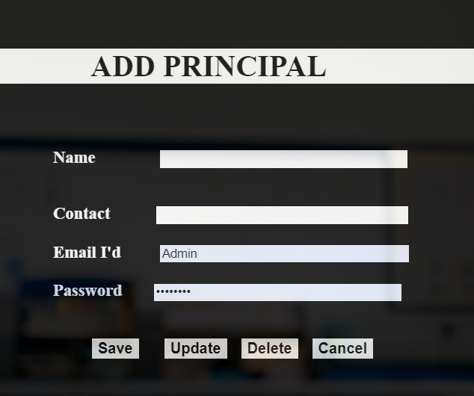

**Student Information:-**



**Parent Information:-**

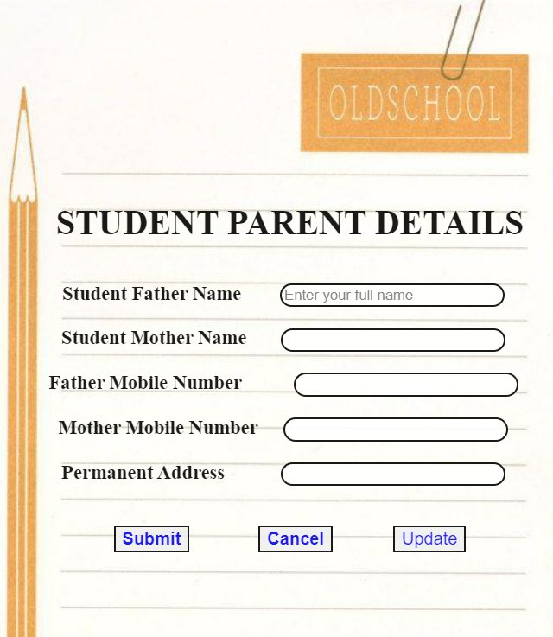

**Fee Detail:-**

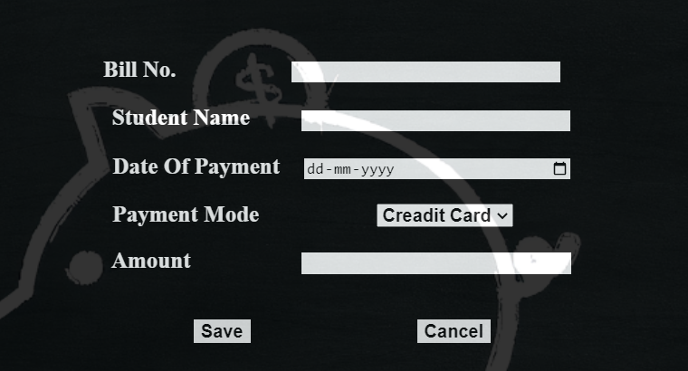

**Chapter-7**

**Output Screens**

**Detail Report:-**

**Student Parents Information:-**

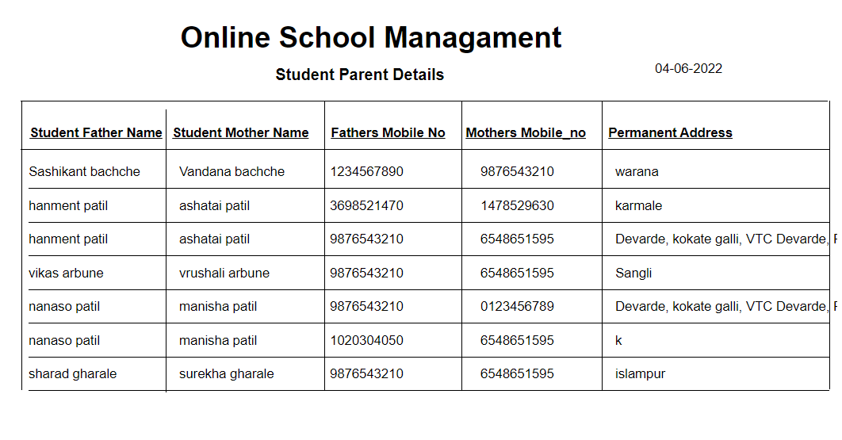

**Fee Detail :-**

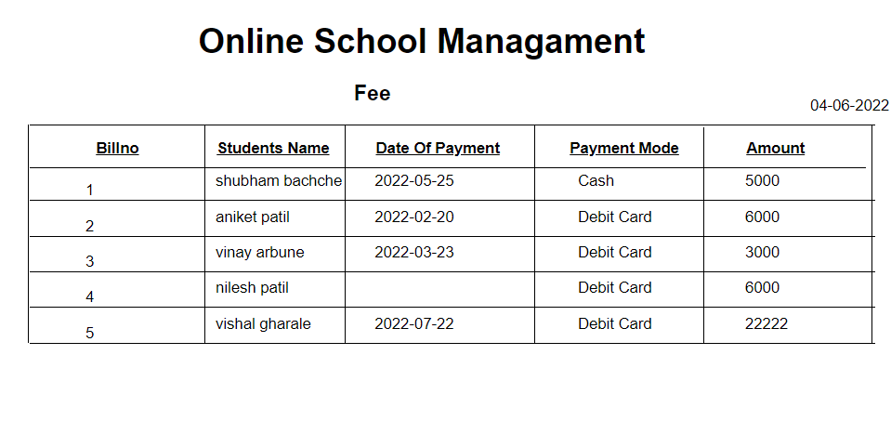

**Academic Details:-**



**Sign Details:-**

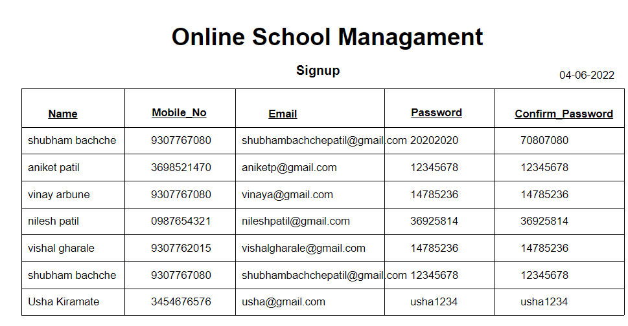

**Chapter-8**

**Limitations and Suggestions**

**Limitations & Suggestions**

Every system has some limitations and because of limitation there is a occurrences of suggestion here we discuss the limitation suggestion of our system “Online School Management system”.

**Limitations:-**

1. This System runs only windows platform
2. This System is not Single user
3. Deleted record cannot be recovered

**Suggestions:-**

1. The user should enter data correctly
2. While getting reports check whether printer is ready or not
3. To start this system ,you have to enter correct password
4. Follow the user manual whenever necessary
5. The user know detail information about the system

**Chapter-9**

**Bibliography**

**Bibliography:-**

**1.** **System Analysis and Design:-**

-By V. Rajaraman

**2. Visual Basic.NET Black Book:-**

-By Steven Holzner.

**3. Analysis and Design of Information System:-**

-By Jemes A.Senn.

**4. Database Management System:-**

-By Raghu amaknishnan and Johanhes Gehrke.